INDOOR CAR SHOW
Auxiliary Room at American Legion Post – 276 8th Ave NW – Ephrata

Raising Funds for Veterans Gift Shop
Select which vehicle(S) you’d like from
Large Collection of Model Vehicles
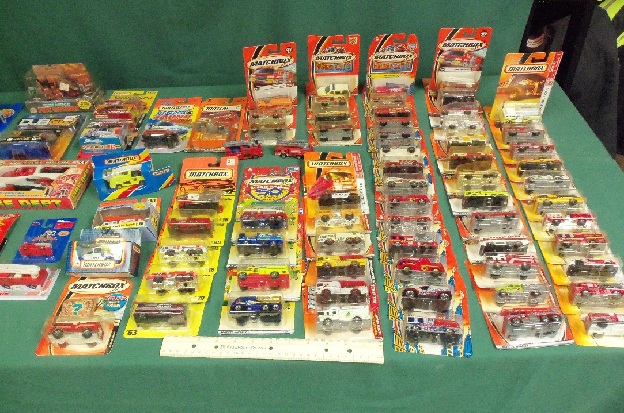
Corgi, Dinky, Seagrave, Road Champs, Matchbox, Hot Wheels, Prestige, Mira, Solido, and many others.
$10 or best offer
Remember good cause when making offer

